Energy efficient doors
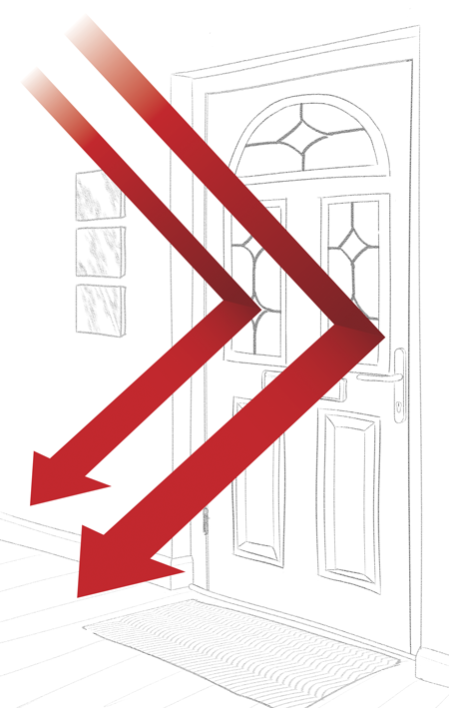
All our doors exceed the current Building Regulations for energy efficiency, which came into force in October 2010, covering front doors for the first time. Under the legislation, all new doors sold and fitted in England and Wales must have a U-value of 1.8W/m2K (1.6W/m2K in Scotland) or less. The door’s U-value is a measure of its energy efficiency, and the lower the U-value, the more energy-efficient the door.
Choosing thermal glass on our doors makes them even more energy-efficient, with an ultimate U-value of just 1.1 W/m2K.
Many manufacturers of doors made of timber, aluminium or PVC panels may struggle to meet the 1.8W/m2K requirement and many do not provide proof.
GRP - the longest product lifespan
Door type | Expected life | Maintenance
Softwood Door | 25 Years | Paint, 5 Years
Hardwood Door | 35 Years | Paint, 5 Years
Steel Composite Door | 30 Years | Wipe Clean
PVC Composite Door | 25 Years | Wipe Clean
GRP Composite Door | 35 Years | Wipe Clean
PVC Panel Door | 20 Years | Wipe Clean
Information from HAPM (Housing Association Provident Mutual) and BRE (Building Research Establishment)
And we have taken big steps to reduce our own carbon footprint too. Our doors are made right here in the UK, unlike the products of other door companies. And we carefully plan and all our delivery routes to cut down the amount of fuel we use.
Other manufacturers look at our doors and go green with envy - we are just greener.

